# MODUL 6

**DIGITAL SYSTEM**



**By:**

**Muhammad Irfan**

**L200184165**

**INFORMATION TECHNOLOGY COMMUNICATION AND INFORMATICS FACULTY MUHAMMADIYAH UNIVERSITY OF SURAKARTA**

1. **Trial 1**

1. Make the logic gate combination based on the following K map!

|  |  |  |  |  |  |
| --- | --- | --- | --- | --- | --- |
|  | | AB | | | |
| 00 | 01 | 11 | 10 |
| CD | 00 | 0 | 0 | 0 | 0 |
| 01 | 1 | 1 | 1 | 0 |
| 11 | 0 | 1 | 1 | 1 |
| 10 | 0 | 0 | 0 | 0 |

1. Boolean function: **F = A’C’D + BD + ACD**
2. Make the logic gates based on your Boolean function!

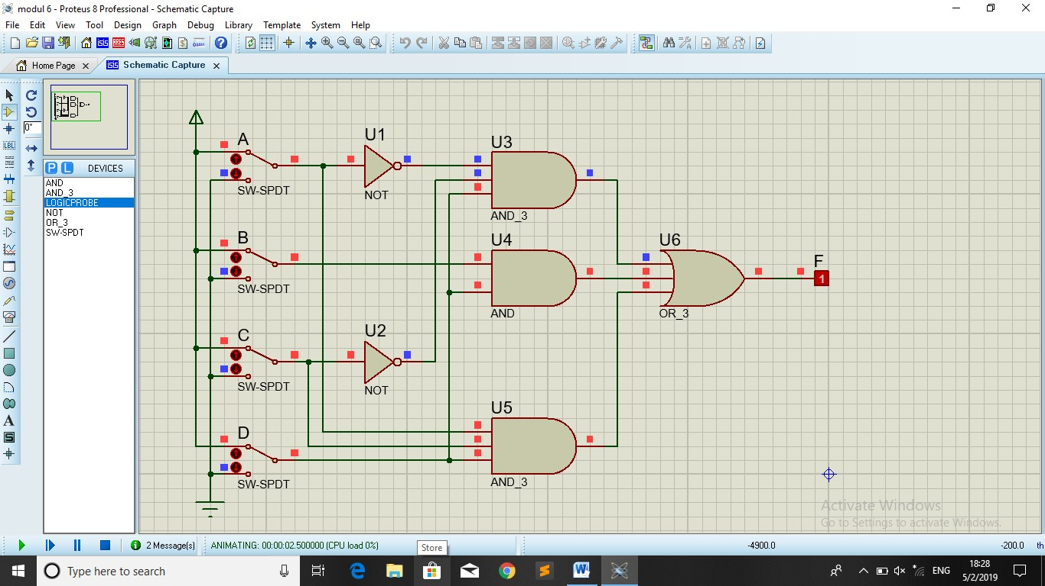

## Trial 2

1. Make the logic gate combination based on the following K map!

|  |  |  |  |  |  |
| --- | --- | --- | --- | --- | --- |
|  | | AB | | | |
| 00 | 01 | 11 | 10 |
| CD | 00 | 1 | 0 | 0 | 1 |
| 01 | 0 | 1 | 1 | 0 |
| 11 | 0 | 1 | 1 | 0 |
| 10 | 1 | 0 | 0 | 1 |

1. Boolean function:

**F = B’D’ + BD** *(AND-OR)*

**F = B’D + BD’** *(OR-AND)*

1. Make the logic gates based on your Boolean function!

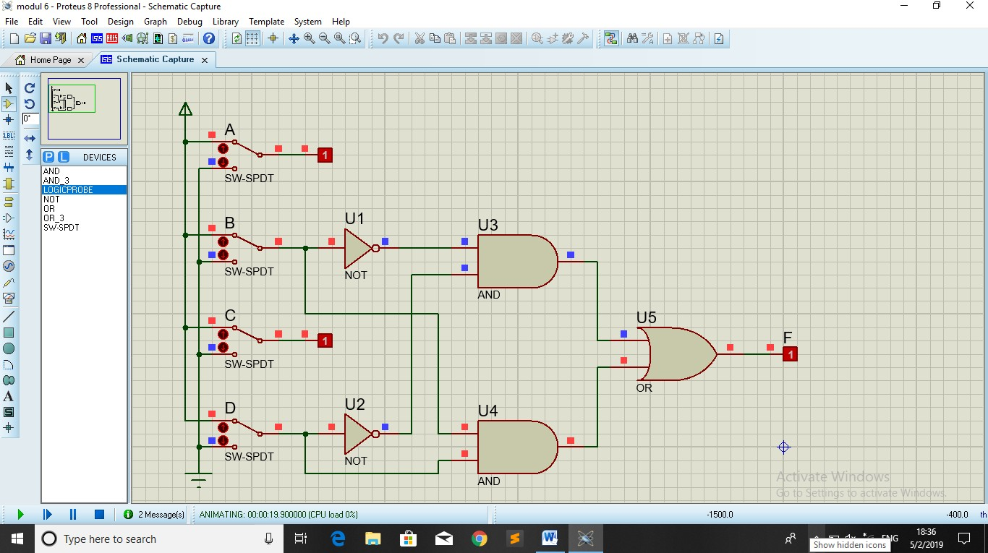

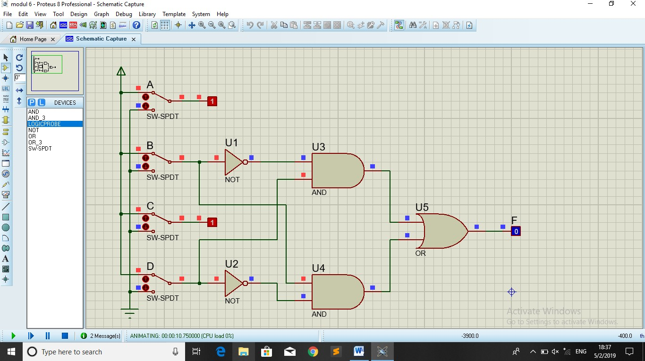

## Trial 3

1. Boolean function: **F = XYZ + XYZ’ + XY’Z + X’YZ + X’YZ’ + XY’Z’ + X’Y’Z’**

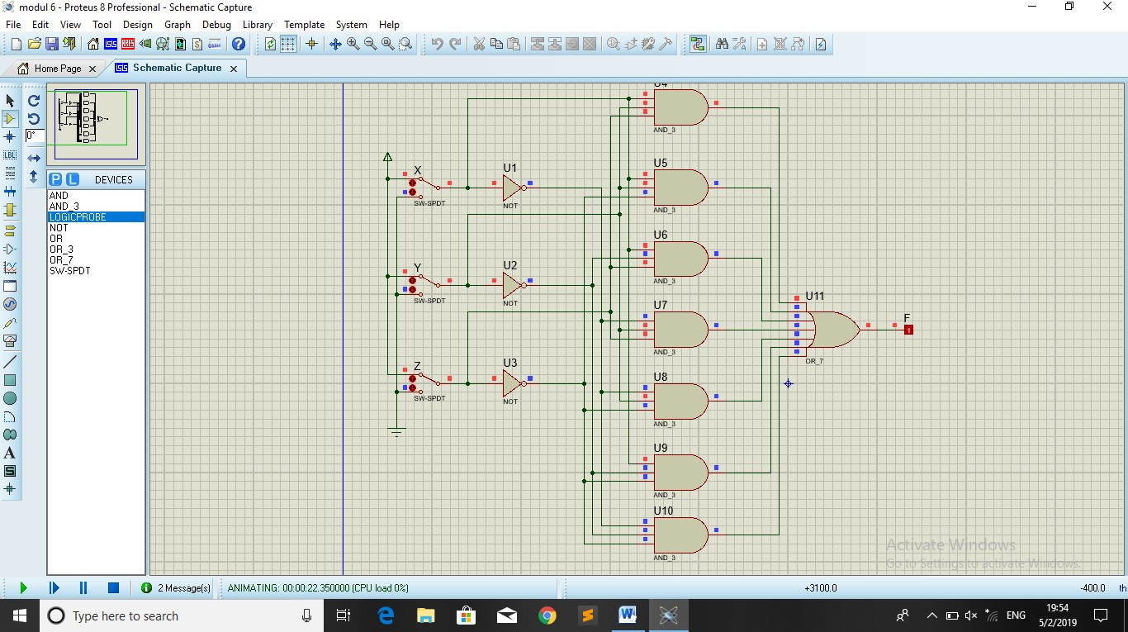

1. Based on the Boolean function, fill the blank in the following K map!

|  |  |  |  |  |  |
| --- | --- | --- | --- | --- | --- |
|  | | XY | | | |
| 00 | 01 | 11 | 10 |
| Z | 0 | 1 | 1 | 1 | 1 |
| 1 | 0 | 1 | 1 | 1 |

1. Simplify the Boolean function: **F = X + Y + Z’**
2. Draw the logic gates based on your Boolean function!

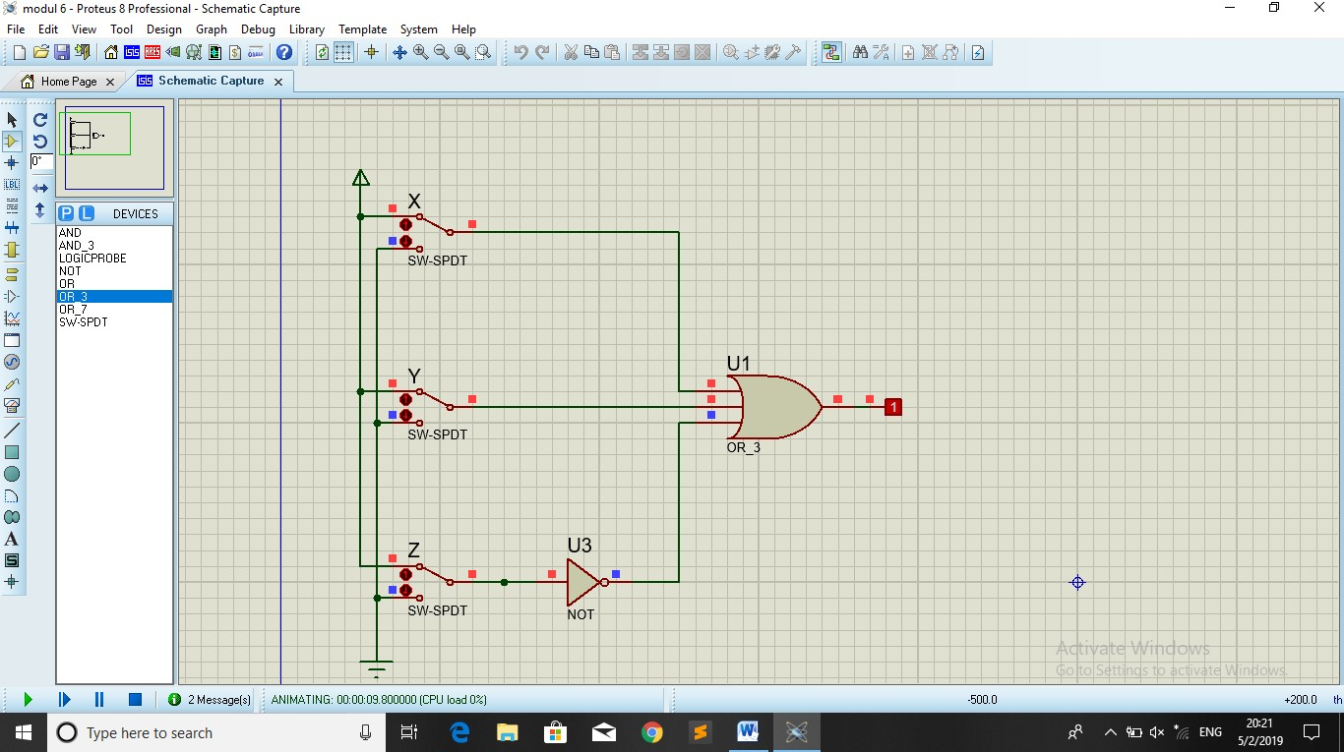

## Trial 4

1. Boolean function: **F = AD’ + ABC + ABC’ + BCD + BC’D’ + AB’CD’**
2. Based on the Boolean function, fill the blank in the following K map!

|  |  |  |  |  |  |
| --- | --- | --- | --- | --- | --- |
|  | | AB | | | |
| 00 | 01 | 11 | 10 |
| CD | 00 | 0 | 1 | 1 | 1 |
| 01 | 0 | 0 | 1 | 0 |
| 11 | 0 | 1 | 1 | 0 |
| 10 | 0 | 0 | 1 | 1 |

1. Simplify the Boolean function: **F = AB + AD’ + B**
2. Draw the logic gates based on your Boolean function!

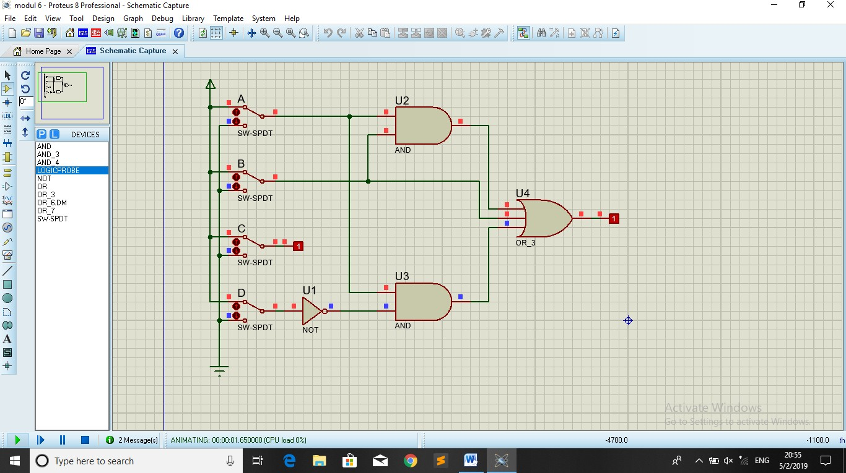

## Trial 5

1. Boolean function table.

|  |  |  |  |  |
| --- | --- | --- | --- | --- |
| **A** | B | C | D | F |
| **0** | 0 | 0 | 0 | 1 |
| 1 | 0 | 0 | 0 | 0 |
| 0 | 1 | 0 | 0 | 0 |
| 1 | 1 | 0 | 0 | 1 |
| 0 | 0 | 1 | 0 | 1 |
| 1 | 0 | 1 | 0 | 1 |
| 0 | 1 | 1 | 0 | 0 |
| 1 | 1 | 1 | 0 | 0 |
| 0 | 0 | 0 | 1 | 1 |
| 1 | 0 | 0 | 1 | 1 |
| 0 | 1 | 0 | 1 | 0 |
| 1 | 1 | 0 | 1 | 1 |
| 0 | 0 | 1 | 1 | 1 |
| 1 | 0 | 1 | 1 | 0 |
| 0 | 1 | 1 | 1 | 1 |
| 1 | 1 | 1 | 1 | 0 |

1. Based on the table, fill the blank on the following K map!

|  |  |  |  |  |  |
| --- | --- | --- | --- | --- | --- |
|  | | AB | | | |
| 00 | 01 | 11 | 10 |
| CD | 00 | 1 | 0 | 1 | 0 |
| 01 | 1 | 0 | 1 | 1 |
| 11 | 1 | 1 | 0 | 0 |
| 10 | 1 | 0 | 0 | 1 |

1. Simplify the Boolean function!

## F = A’B’ + B’ + A’CD + C’

1. Draw the logic gates based on your Boolean function!

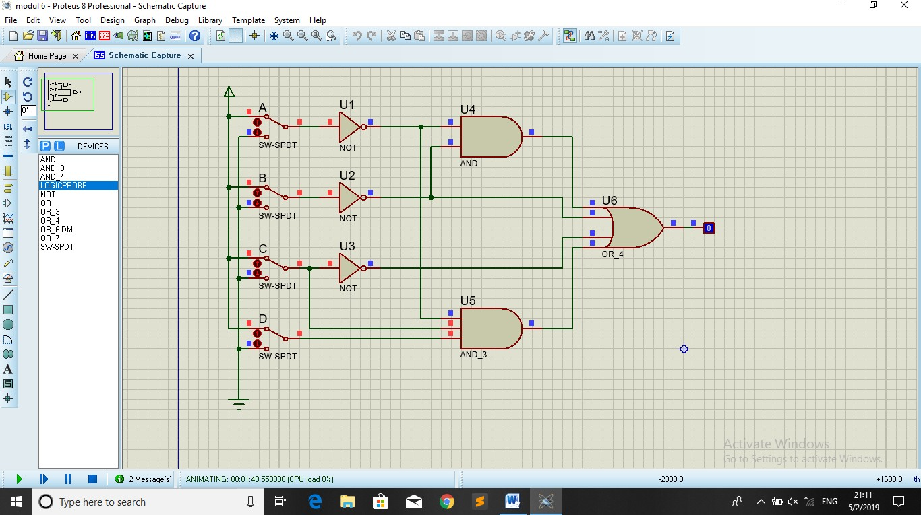

*Is all the two combinations give the same result?* **NO**